Page Designer Plus

*Version 22.1.0*



Table of Contents

1. Summary 4

What is page designer plus? 4

2. Component Overview 5

Functional Overview 5

Multilingual support 5

Use Cases 5

Video Component. 5

This video component was designed to support following video hosting platforms. 5

Use Case A: Add a simple video to a page. 6

Use Case B: Opening a Video in modal component 10

Extended Slider Component. 11

Use Case A: Configuring Extended Banner 11

Use Case B: Configuring Extended Slider Component 15

HTML Markup Component 20

Use Case: Add an HTML Markup component to a page.. 20

Marketing Tiles 24

Use Case A: Configuring Simple Marketing Tiles Component 24

Use Case B: Configuring Advance Overlay Marketing Tiles Component 30

Content Asset Component 37

Use Case: Configuring Content Asset component. 37

Limitations, Constraints 39

Compatibility 40

Privacy, Payment 40

3. Implementation Guide 41

Setup of Business Manager 41

Configuration 41

Custom Code 41

External Interfaces 41

Firewall Requirements 41

4. Testing 42

5. Operations, Maintenance 43

Data Storage 43

Availability 43

Failover/Recovery Process 43

Support 43

6. User Guide 44

Roles, Responsibilities 44

Business Manager 44

Storefront Functionality 44

7. Known Issues 44

8. Release History 44

# Summary

## Page Designer Vs Page Designer Plus an introduction:

salesforce provides a framework Page designer for merchants to quickly design static and dynamic page layouts without going into technical details by using predefined and custom layouts and components provided by this frame work. Salesforce also provides a sample plugin cartridge to demonstrate how to create custom components and layouts. Although Page designer is a rich framework but as its maturing there are many areas that needs improvement and enhancements to provide merchant with tools and components to quickly build their pages using ready to use components.

Page designer plus enhances existing page designer components and adds more components to it saving merchant Significant amount of time and effort to build similar components and enables them to quickly design and deploy their application using enhanced components by page designer plus without worrying about development time and testing it would take to create such components from scratch. Page designer plus is built on top of existing page designer plugin cartridge available in community repository.

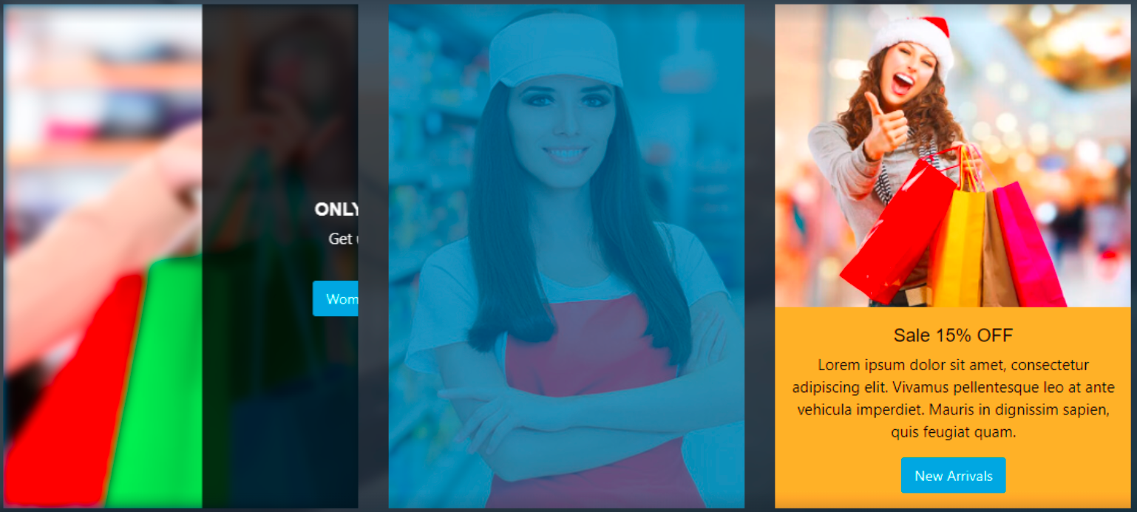

# Component Overview

## Functional Overview

Page designer Plus provides 5 custom components and additional layouts that enables merchant to quickly build pages using these custom components and others available in page designer plugin cartridge. This cartridge provides following components.

* Video Component
* Extended Slider / Banner Component
* HTML Markup Component
* Enhanced Marketing Tile
* Content Asset Component

## Use Cases

### Video Component.

Page designer OOTB does not provide any component to run videos from social sites or any hosted videos. Page designer plus supports inserting videos into page designer pages with ease and control over rendering. This component saves lots of time and effort for merchant to quickly publish videos from platform of choice and insert them anywhere on page designer pages. The video component also supports opening in modal popup example of which can be found in documentation.

## 

## This video component is designed to support following video hosting platforms.

* You Tube
* Vimeo
* html5 Video player with remote URL
* daily Motion
* Custom URL (iframe embedded)

Merchant Can easily Select

* Video dimensions
* Video Resolution
* Mute Video
* Auto Play on start
* Loop Video
* Fill container
* Show in modal Popup
* Thumbnail for Pop up video

#### Use Case A: Add a simple video to a page.

**Navigate to Merchant Tools > Page Designer**

1. Create a new page by clicking **New**,select **PDPlus Storefront Page** and then click **Next**  
     
   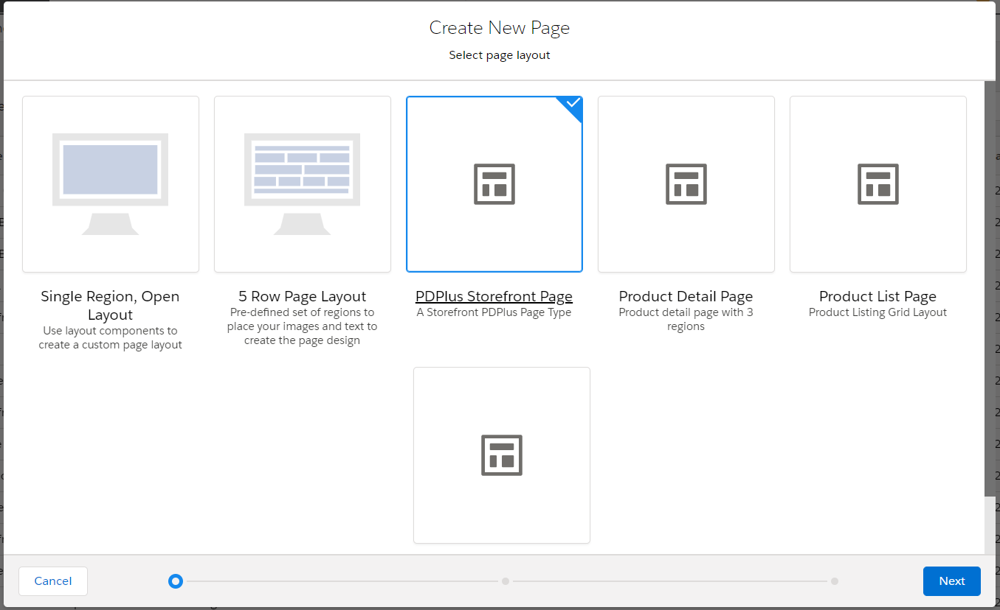

1. Add Name, ID, Description (optional) of your page and press **Next** button and then press **Save & Create** button  
     
   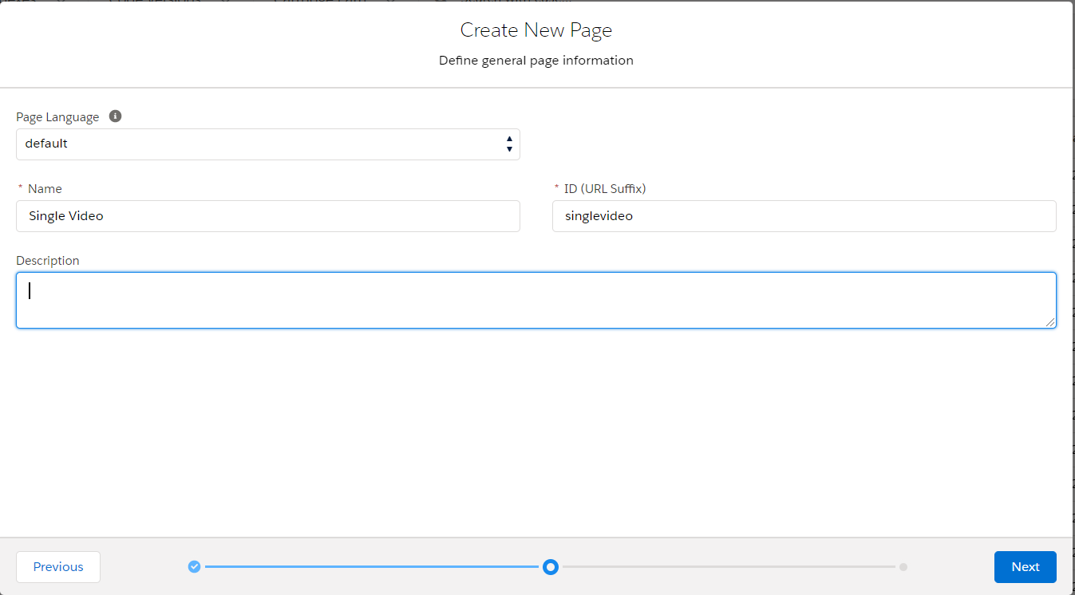
2. From page designer Interface, press **‘+’** from **Main Region** and select **PD Plus Grid 1Rx1C** under ***PD_LAYOUTS*** section.  
     
   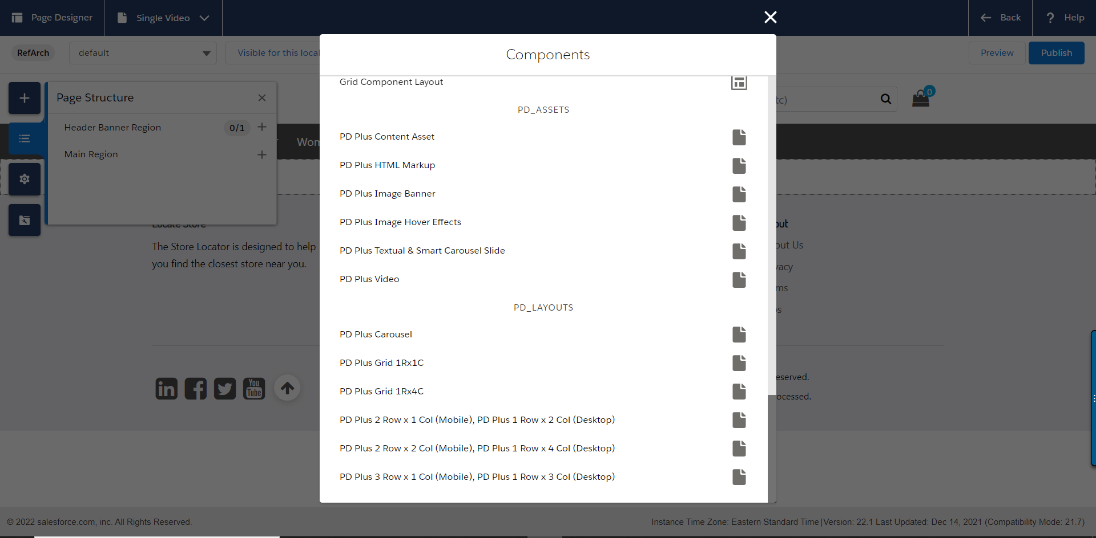

Fill your customize settings for **PD Plus Grid 1Rx1C** Component and then press **Save** Button

|  |  |
| --- | --- |
| Field Name | Value |
| Component Settings |  |
| Layout Fluid | Unchecked |
| Specify Background Color | #011126 |
| Specify Background Color Alpha between 0 and 1 i.e 0.2 | 70 |
| Specify Background Image | meta/images/demo/sanfranciscobackground3.jpg |
| Specify Image Alt text | San Francisco background image |
| UI Layout Settings |  |
| Padding Top | 15px |
| Padding-Right | 15px |
| Padding-Bottom | 15px |
| Padding Left | 15px |
| Margin Top | 20px |
| Margin Right |  |
| Margin Bottom |  |
| Margin Left | 20px |

**Sample Configurations:**

|  |  |
| --- | --- |
|  |  |

1. In Page Designer Interface, press **‘+’** on right side of **PD Plus Column 1** and then click **PD Plus Video** Component under **PD_ASSETS**
2. Sample Video Player Configurations:

|  |  |
| --- | --- |
| Field Name | Value |
| Video Player Configurations |  |
| CSS Class name for Video background i.e. bg-dark |  |
| Select Video | Youtube |
| Video ID | T3GLrLWsWNo |
| Video Scale |  |
| Player Control Settings |  |
| AutoPlay | Checked |
| Mute Video | Checked |
| Loop Video | Checked |
| Allow Full Screen | Checked |
| Video Resolution |  |
| Video Thumbnail |  |
| Image Alternate Text |  |
| Open Video in Modal Popup | Uncheck |
| Play Icon | Uncheck |

**Sample Images:**

|  |  |
| --- | --- |
|  |  |

1. Tick the following desired settings from **Player Control Settings** for your video component:
   1. Auto play
   2. Mute Video
   3. Loop Video
   4. Allow Full Screen
   5. Video Resolution

Press Save and View page you should be able to view the video like following on the page.

You can use the margin and padding fields to adjust the component according to requirement.

**Preview Page:**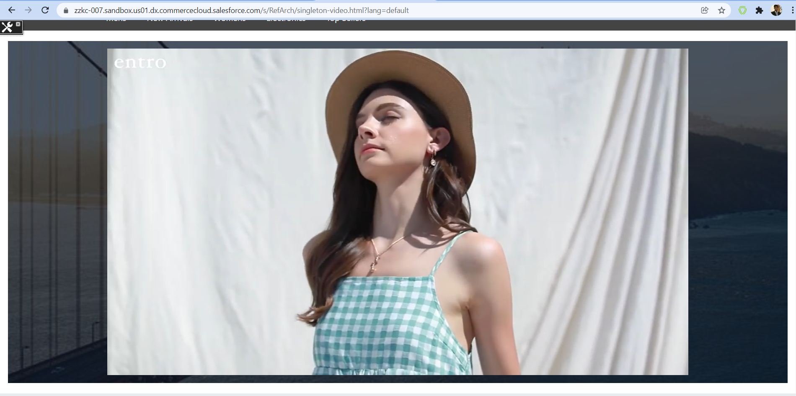

#### Use Case B: Opening a Video in modal component

Along the aforementioned settings, if you want to display **video in a Modal Pop up** then do the following in the same component:

1. Click the checkbox Open Video in Modal Popup
2. Add image in Video Thumbnail
3. Place some text in Image Alternate Text
4. Click **Play Icon** checkbox

**Sample Configuration Image:**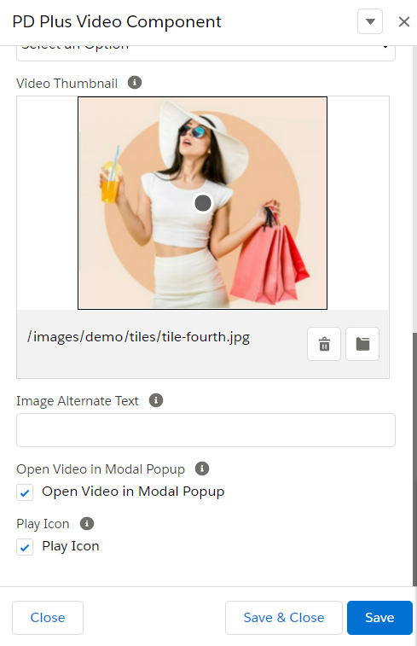

You should be able to see the video like following after saving and clicking on image.

**Preview Images:**

|  |  |
| --- | --- |
|  |  |

### Extended Slider Component.

SFRA slider does not provide merchant with ease of adding custom text and videos. Which limits the merchant in terms of creativity? The slider lacks option to Use videos and Content assets within the slider.The new Page designer Plus slider Reduces time it would require to build custom component for showing videos and assets inside the slider via page designer, thus cutting down cost and time to implement the same feature significantly.

.

**Features**

* “Custom layout “available to be used along with this component to support custom background image and displaying content in two columns separating video and Content Asset.
* Ability to Add Video component to OOTB page Slider Component with full control over AutoStart, resolution, mute, and other video controls.
* Ability Set Padding/Margin for “layout” to control position of elements.
* Ability to display slider in fluid layout or regular.
* Ability to use content assets for rendering text inside banner opposed to existing OOTB component.
* Ability to swap locations of Video and Content Assets for desktop view to show them on left or right of each other.
* Unlimited number of slides videos and assets supported.
* Ability use the component as stand-alone banner or as a part of slider as slide for slider component

#### Use Case A: Configuring Extended Banner

Add an extended banner to a page.

**Navigate to** Merchant Tools > Page Designer

1. Create a new page by clicking **New**,select **PDPlus Storefront Page** and then click **Next**  
     
   
2. Add Name, ID, Description (optional) of your page and press **Next** button and then press **Save & Create** button

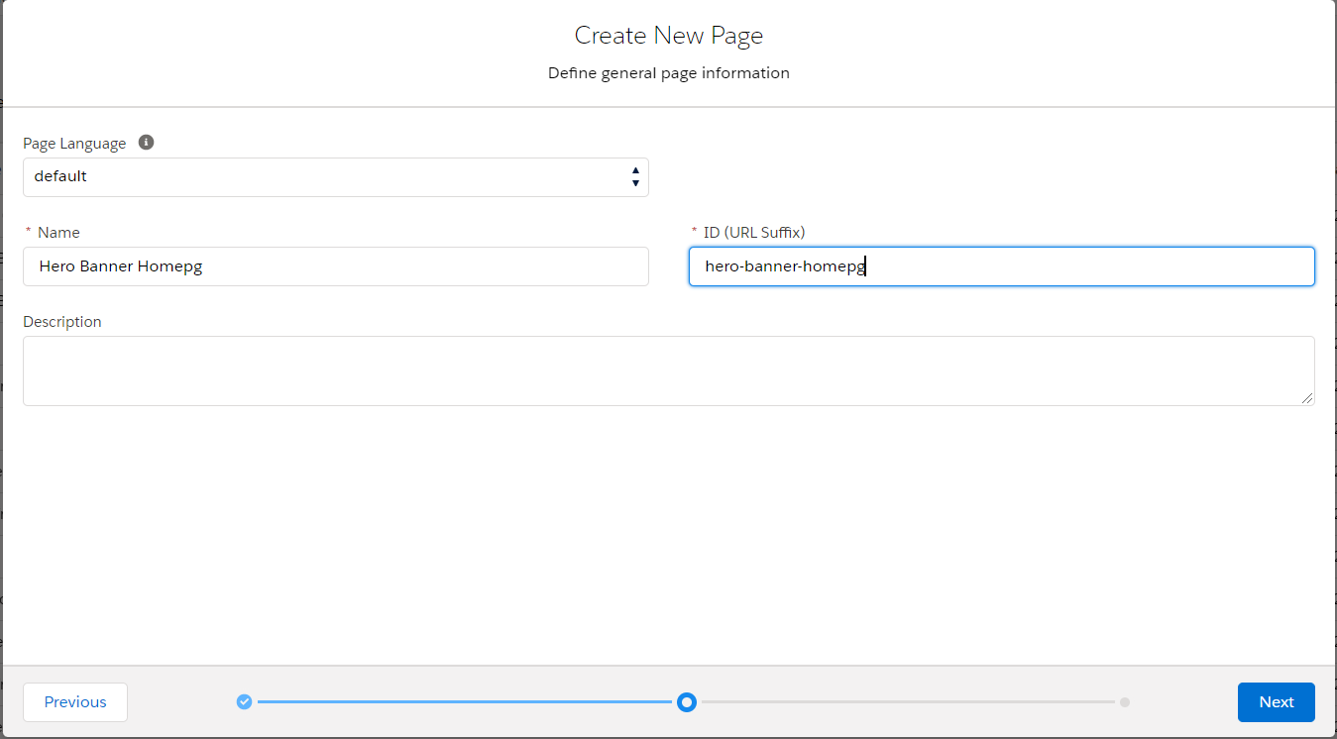

1. From page designer Interface, press **‘+’** from **Main Region** and select **PD Plus Grid 1Rx1C** under ***PD_LAYOUTS*** section.

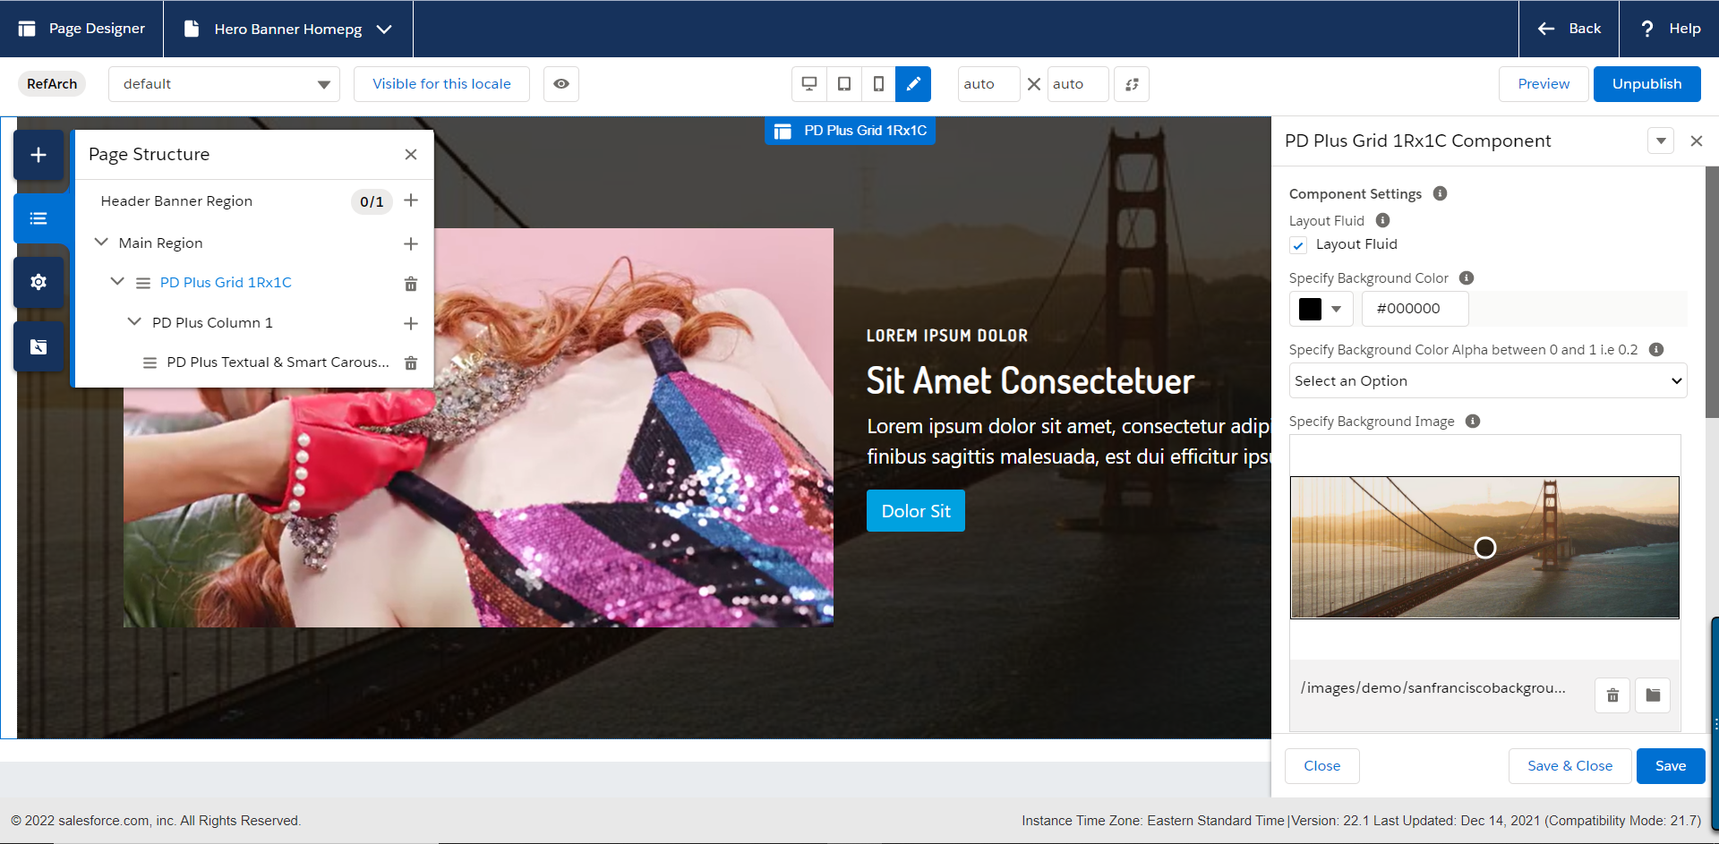

1. Fill your customize settings for **PD Plus Grid 1Rx1C** Component and then press **Save** Button

|  |  |
| --- | --- |
| Field Name | Value |
| Component Settings |  |
| Layout Fluid | Checked |
| Specify Background Color | #000000 |
| Specify Background Color Alpha between 0 and 1 i.e 0.2 | 70 |
| Specify Background Image | meta/images/demo/sanfranciscobackground3.jpg |
| Specify Image Alt text | San Francisco background image |
| UI Layout Settings |  |
| Padding Top |  |
| Padding-Right | 15px |
| Padding-Bottom |  |
| Padding Left | 15px |
| Margin Top | 20px |
| Margin Right |  |
| Margin Bottom |  |
| Margin Left | 20px |

1. Now click on ‘+’ sign and add **PD Plus Textual & Smart Carousel Slide** in **PD Plus Column 1**

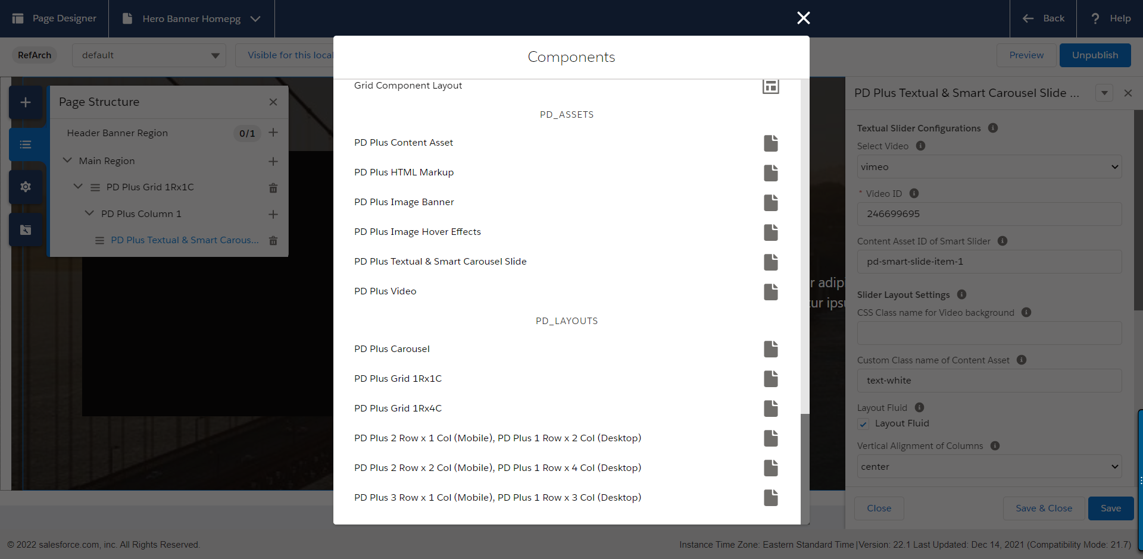

1. Sample Configurations for **PD Plus Textual & Smart Carousel Slide** are**:**

|  |  |
| --- | --- |
| Field Name | Value |
| Textual Slider Configurations |  |
| Select Video | Vimeo |
| Video ID | 246699695 |
| Content Asset ID of Smart Slider | Use content asset id of your choice |
| Slider Layout Settings |  |
| CSS Class name for Video background |  |
| Custom Class name of Content Asset | text-white |
| UI Layout Settings |  |
| Layout Fluid | Checked |
| Vertical Alignment of Columns | Center |
| Order of Smart Text Column | 1 |
| Order of Smart Video Column | 0 |
| Video Component Configurations |  |
| Autoplay | Checked |
| Mute Video | Checked |
| Loop Video | Checked |
| Allow Full Screen | Checked |
| Video Resolution |  |

1. Press Save, publish and preview of the page is**:**

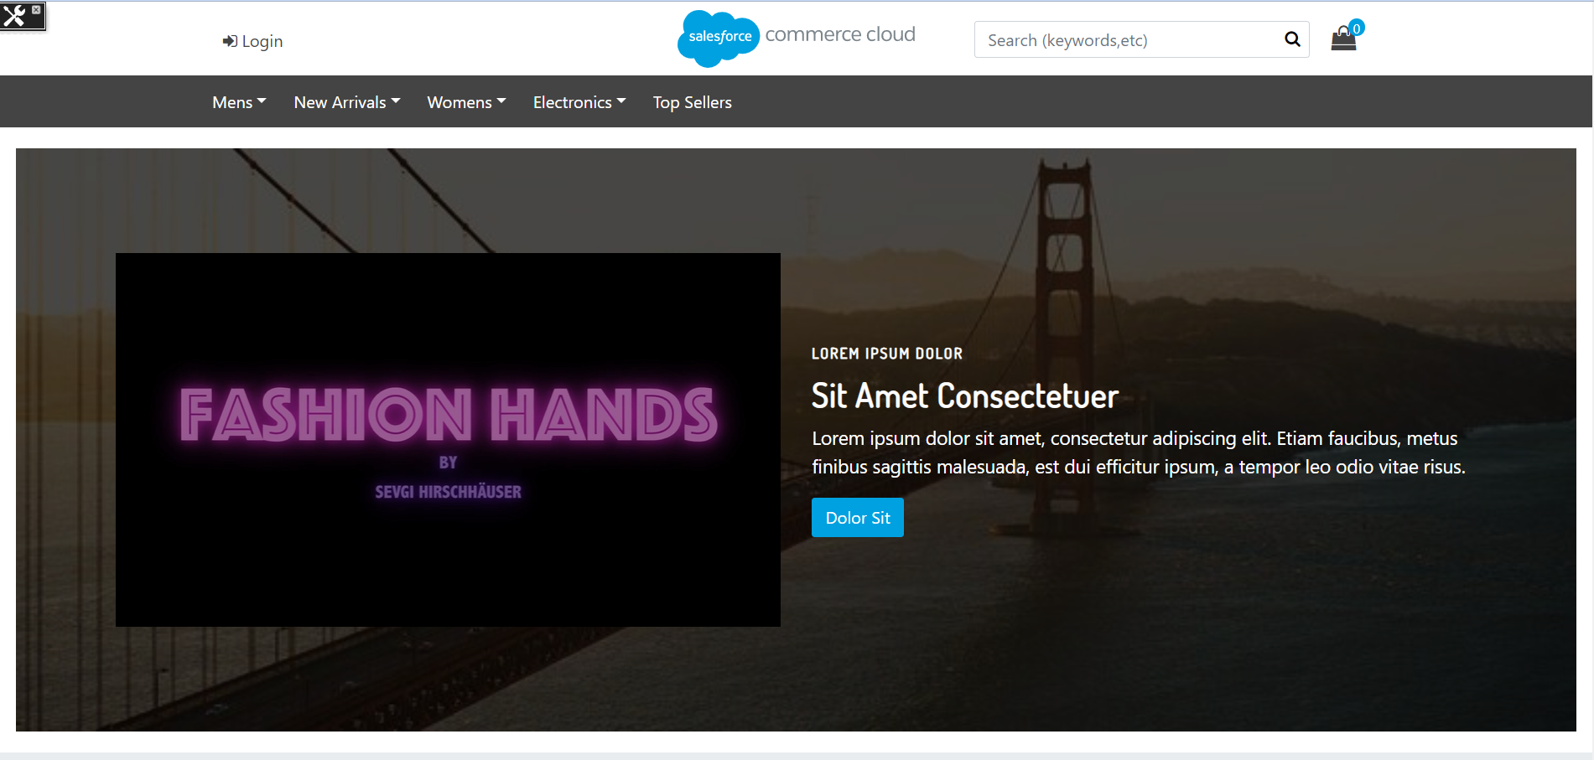

#### Use Case B: Configuring Extended Slider Component

Add an extended carousel slider to a page with configured content asset.

**Navigate to Merchant Tools > Page Designer**

1. Create a new page by clicking **New**,select **PDPlus Storefront Page** and then click **Next**  
     
   
2. Add Name, ID, Description (optional) of your page and press **Next** button and then press **Save & Create** button  
   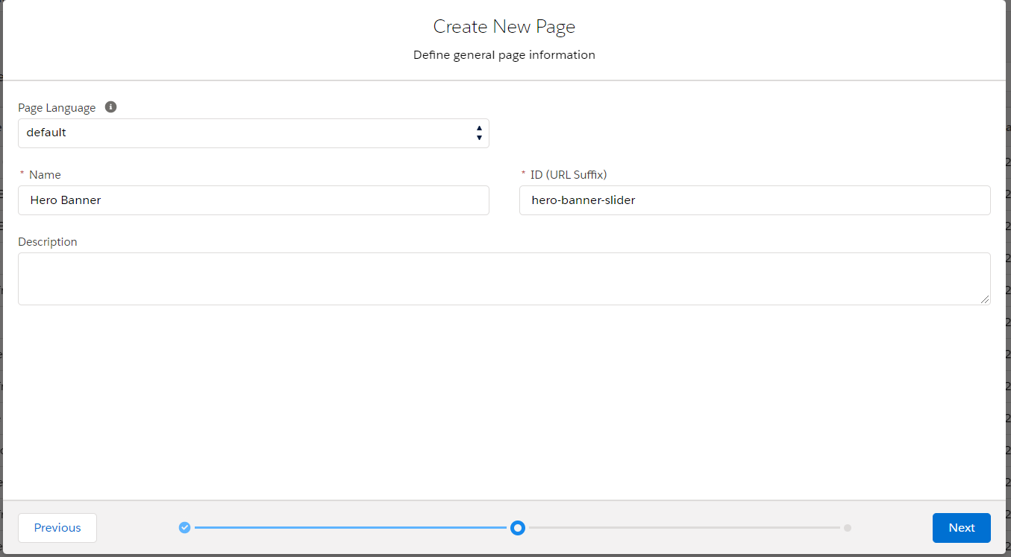

From page designer Interface, press **‘+’** from **Main Region** and select **PD Plus Grid 1Rx1C** under ***PD_LAYOUTS*** section.  
  
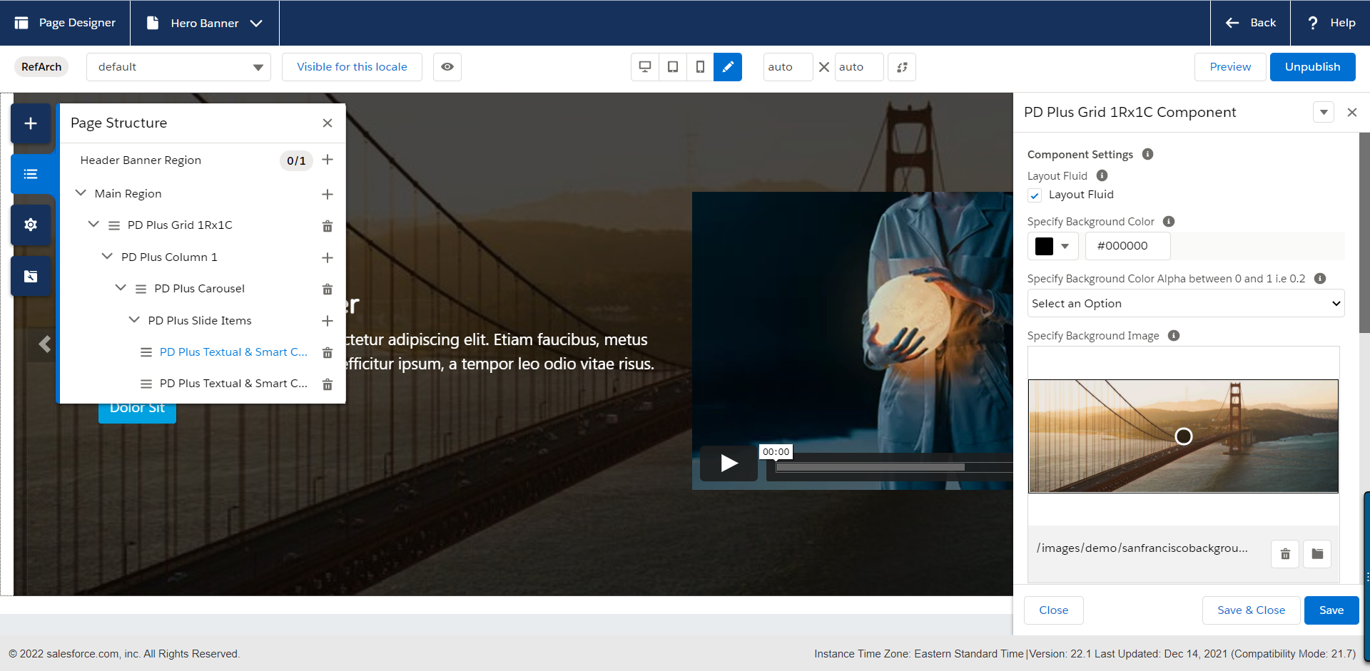

You can use the margin and padding fields to adjust the component according to requirement.

1. Fill your customize settings for **PD Plus Grid 1Rx1C** Component and then press **Save** Button

|  |  |
| --- | --- |
| Field Name | Value |
| Component Settings |  |
| Layout Fluid | Checked |
| Specify Background Color | #000000 |
| Specify Background Color Alpha between 0 and 1 i.e 0.2 | 70 |
| Specify Background Image | meta/images/demo/sanfranciscobackground3.jpg |
| Specify Image Alt text | San Francisco background image |
| UI Layout Settings |  |
| Padding Top |  |
| Padding-Right | 15px |
| Padding-Bottom |  |
| Padding Left | 15px |
| Margin Top | 20px |
| Margin Right |  |
| Margin Bottom |  |
| Margin Left | 20px |

1. Now click on ‘+’ sign and add **PD Plus Carousel** in **PD Plus Column 1**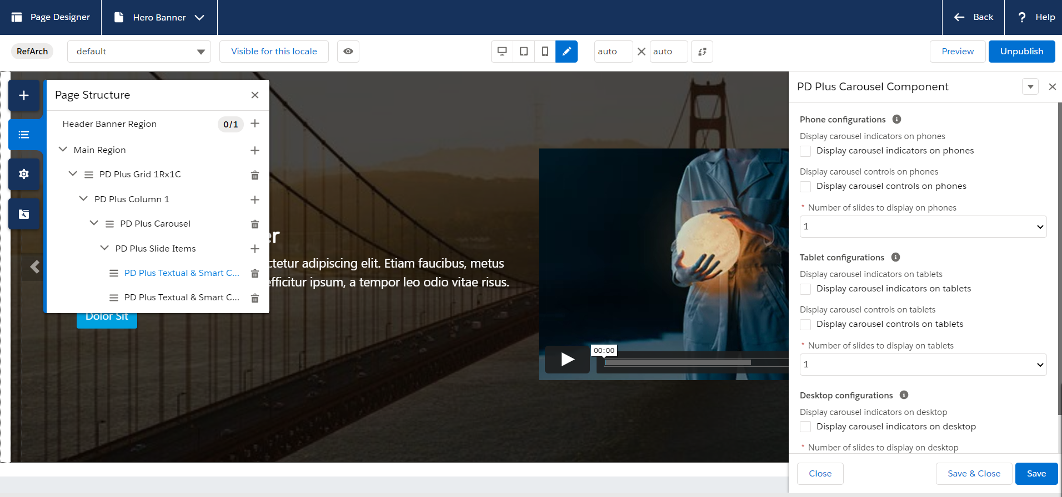
2. Sample Configurations for PD Plus Carousel are:

|  |  |
| --- | --- |
| Field Name | Value |
| Phone configurations |  |
| Display carousel indicators on phones | Unchecked |
| Display carousel controls on phones | Unchecked |
| Number of slides to display on phones | 1 |
| Tablet configurations |  |
| Display carousel indicators on tablets |  |
| Display carousel controls on tablets |  |
| Number of slides to display on tablets | 1 |
| Desktop configurations |  |
| Display carousel indicators on desktop |  |
| Number of slides to display on desktop | 1 |

1. Now click ‘+’ to add **PD Plus Slide Items**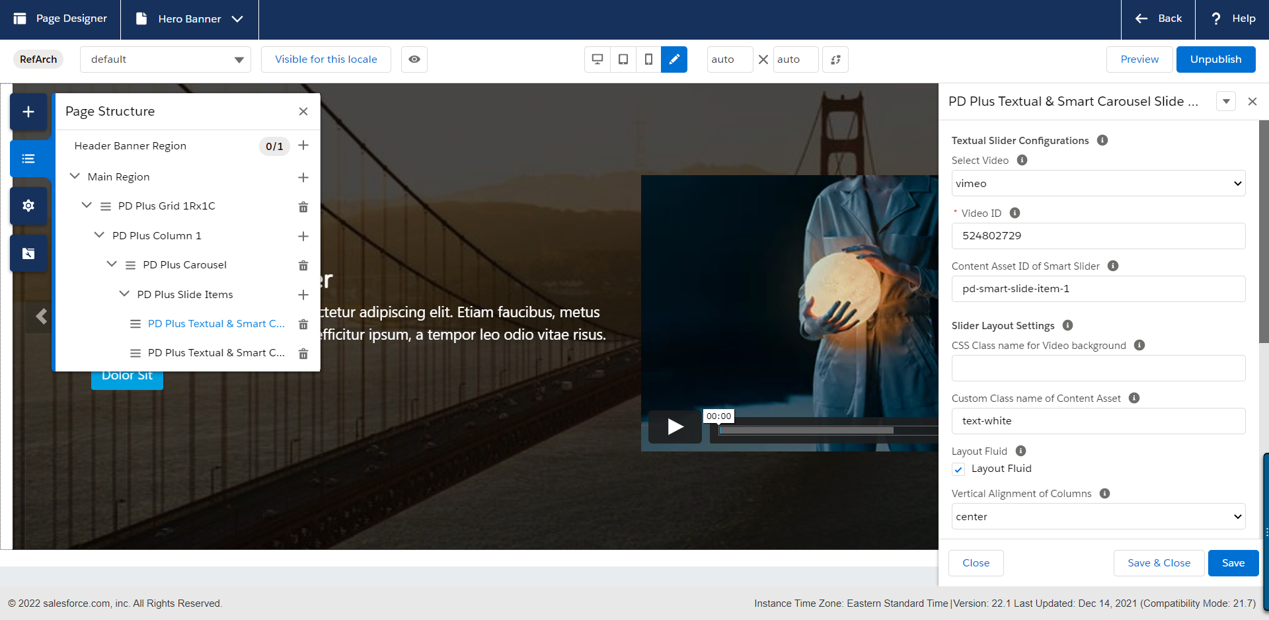
2. Click ‘+’ to add more **PD Plus Slide Items** in **PD Plus Carousel** Component  
     
   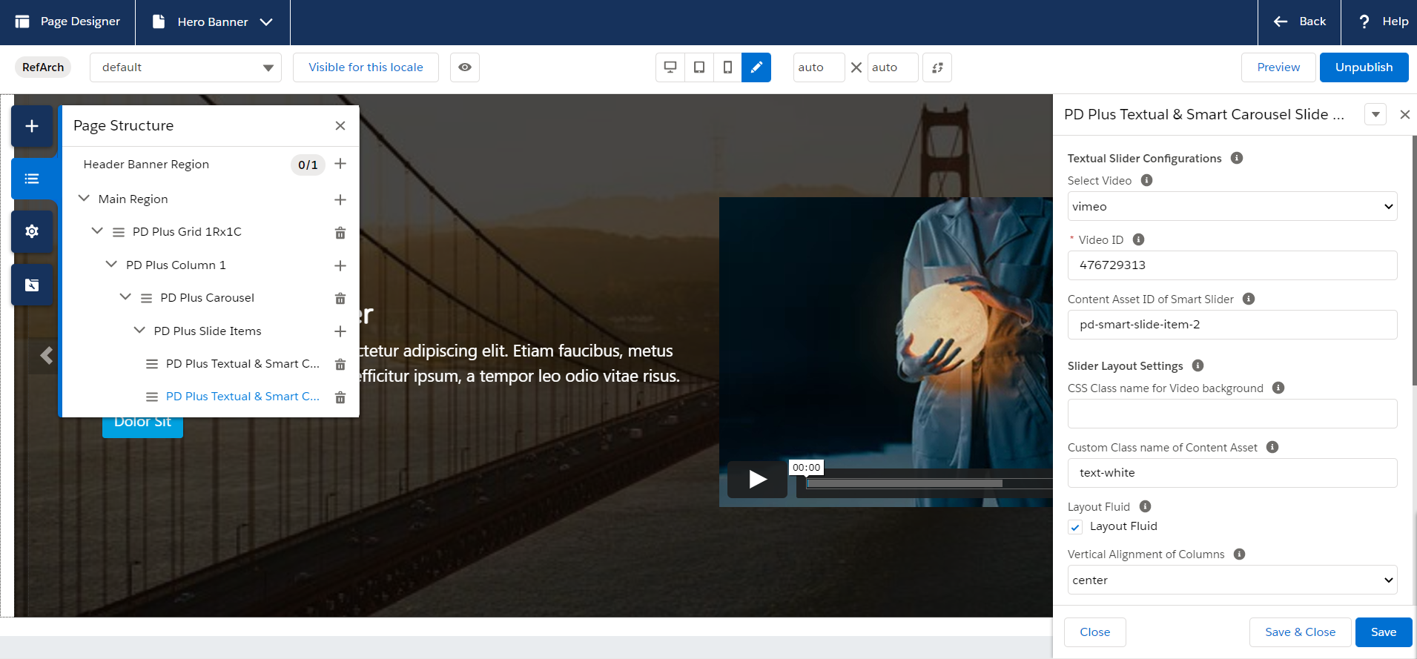
3. Sample Configurations for PD Plus Slide Items:  
     
   **Settings for PD Plus Slide Item 1**

|  |  |
| --- | --- |
| Field Name | Value |
| Textual Slider Configurations |  |
| Select Video | Vimeo |
| Video ID | 524802729 |
| Number of slides to display on phones |  |
| Content Asset ID of Smart Slider | Use content asset id of your choice |
| Slider Layout Settings |  |
| CSS Class name for Video background |  |
| Custom Class name of Content Asset | text-white |
| Layout Fluid | Checked |
| Vertical Alignment of Columns | Center |
| Order of Smart Text Column | 0 |
| Order of Smart Video Column | 1 |
| Video Component Configurations |  |
| Autoplay | Checked |
| Mute | Checked |
| Loop Video | Checked |
| Allow Full Screen | Unchecked |
| Video Resolution |  |

**Settings for PD Plus Slide Item 2**

|  |  |
| --- | --- |
| Field Name | Value |
| Textual Slider Configurations |  |
| Select Video | Vimeo |
| Video ID | 476729313 |
| Number of slides to display on phones |  |
| Content Asset ID of Smart Slider | Use content asset id of your choice |
| Slider Layout Settings |  |
| CSS Class name for Video background |  |
| Custom Class name of Content Asset | text-white |
| Layout Fluid | Checked |
| Vertical Alignment of Columns | Center |
| Order of Smart Text Column | 1 |
| Order of Smart Video Column | 0 |
| Video Component Configurations |  |
| Autoplay | Unchecked |
| Mute | Checked |
| Loop Video | Checked |
| Allow Full Screen | Checked |
| Video Resolution |  |

1. Press Save, publish and preview the page.

|  |  |
| --- | --- |
|  |  |

### HTML Markup Component

Html Markup component is an easy-to-use component which allows merchant to quick embed html styled text with custom background color and texture to be added on any page. This in turn saves lots of time of his to recreate similar html pages and allows to reuse same component without going into details of coding and styling.

Allows Merchant To place Reusable HTML Markup component on multiple pages with custom styling, layout and configurable background texture. with HTML markup Component Merchant can control

* Background Color of Component
* Customizable Heading Text
* Customizable Sub Text
* Control over Text Color
* Control over Content Direction (Top-Left/Top-Centre/Top-Right/Centre-Centre/Centre-Right…)
* Control over Text Alignment (Left/Right/Centre)
* Ability to choose from 16 built in background patterns
* Ability to Add Button for External link
* Ability to Add Button for Internal Link to content or Page
* Ability to Add custom classes for displaying different styles of bootstrap OOTB buttons.

#### Use Case: Add an HTML Markup component to a page..

**Navigate to Merchant Tools > Page Designer**

1. Create a new page by clicking **New**,select **PDPlus Storefront Page** and then click **Next**



1. Add Name, ID, Description (optional) of your page and press **Next** button and then press **Save & Create** button  
   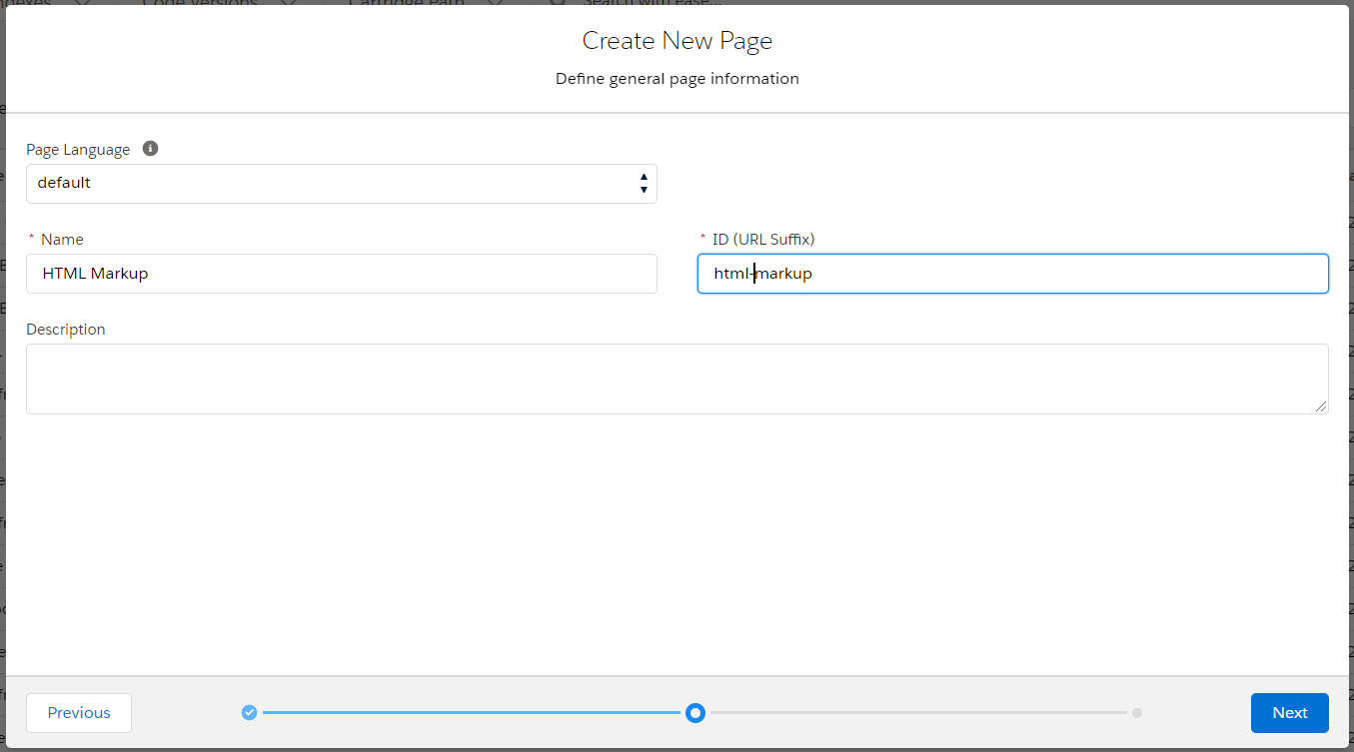
2. At **Main Region**, click ‘**+**’ sign and select **PD Plus Grid 1Rx3C** from **PD_LAYOUTS** section and then fill your customize settings for **PD Plus Grid 1Rx3C** Component and then press **Save** Button.

|  |  |
| --- | --- |
| Field Name | Value |
| Component Settings |  |
| Layout Fluid | Checked |
| Specify Background Color | #000000 |
| Specify Background Color Alpha between 0 and 1 i.e 0.2 | 70 |
| Specify Background Image | meta/images/demo/sanfranciscobackground3.jpg |
| Specify Image Alt text | San Francisco background image |
| UI Layout Settings |  |
| Padding Top | 20px |
| Padding-Right | 15px |
| Padding-Bottom | 20px |
| Padding Left | 15px |
| Margin Top | 20px |
| Margin Right |  |
| Margin Bottom |  |
| Margin Left | 20px |

**Note:** (The default value for Background Color Alpha is 70. You may select your desired value from dropdown).

**Sample Image:**  
  
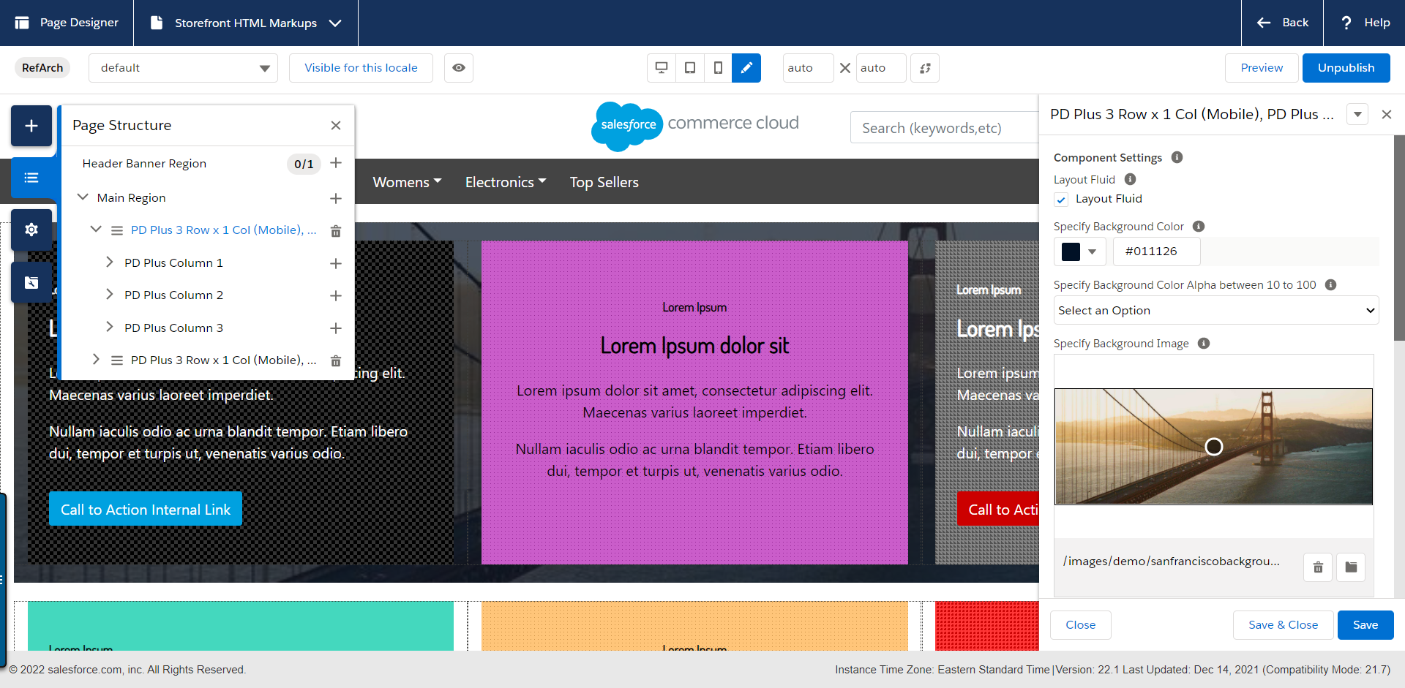

1. Now click ‘**+**’ for each ***PD Plus Column 1***, ***PD Plus Column 2, PD Plus Column 3*** and select **PD Plus HTML Markup** Component from **PD_ASSETS** section.  
     
   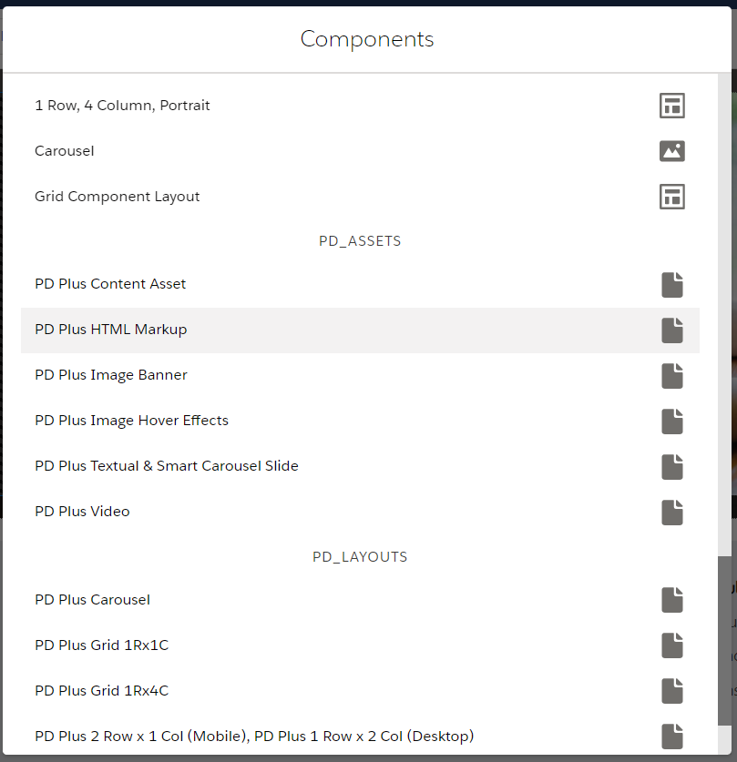
2. Sample configurations for **PD Plus HTML Markup** are:  
   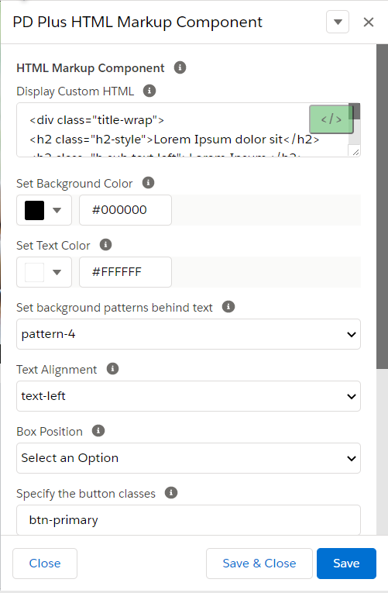
3. Sample Data for **PD Plus HTML Markup** Component:

|  |  |
| --- | --- |
| Field Name | Value |
| HTML Markup Component |  |
| Display Custom HTML | Use your desired HTML Markup |
| Set Background Color | #000000 |
| Set Text Color | #ffffff |
| Set background patterns behind text | Pattern-4 |
| Text Alignment | Text-left |
| Box Position |  |
| Specify the button classes | btn-primary |
| Display Button | Checked |
| Place Button URL | Select Button URL by pressing Create Button |
| Place Button Text | Place your Button text here |
| Open in New Tab | Unchecked |

1. Press Save, publish and preview the page.  
    **Sample Preview Image:**  
     
   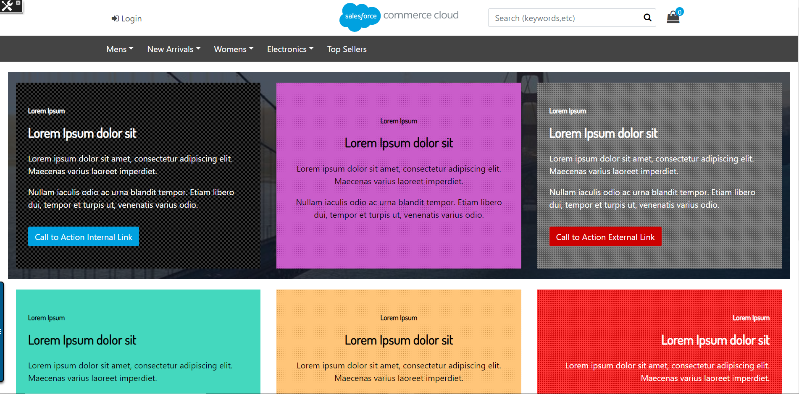

### Marketing Tiles

Allows merchant to quickly embed images tiles for marketing saving time to configure and deploy. The marketing Tiles component provides following features.

* Ability to Choose background image of Tile
* Ability to Apply Image filter from list of available filters such as (Blur, Brightening images, Contrast, Shadow below image, Hue Image, Hue Invert, Opacity, Image Saturation, Image Cepia)
* Ability to Enable disable Hover Effects with customization options
* Wide list of hover effects to choose from 44 animation effects
* Ability to Use Background color of tile and Textbox with opacity
* Control over Text of Tile such as color and alignments
* Image Title fields available for SEO.
* Option to Add button for internal external link

### Use Case A: Configuring Simple Marketing Tiles Component

**Navigate to Merchant Tools > Page Designer**

1. Create a new page by clicking **New**,select **PDPlus Storefront Page** and then click **Next**



1. Add Name, ID, Description (optional) of your page and press **Next** button and then press **Save & Create** button

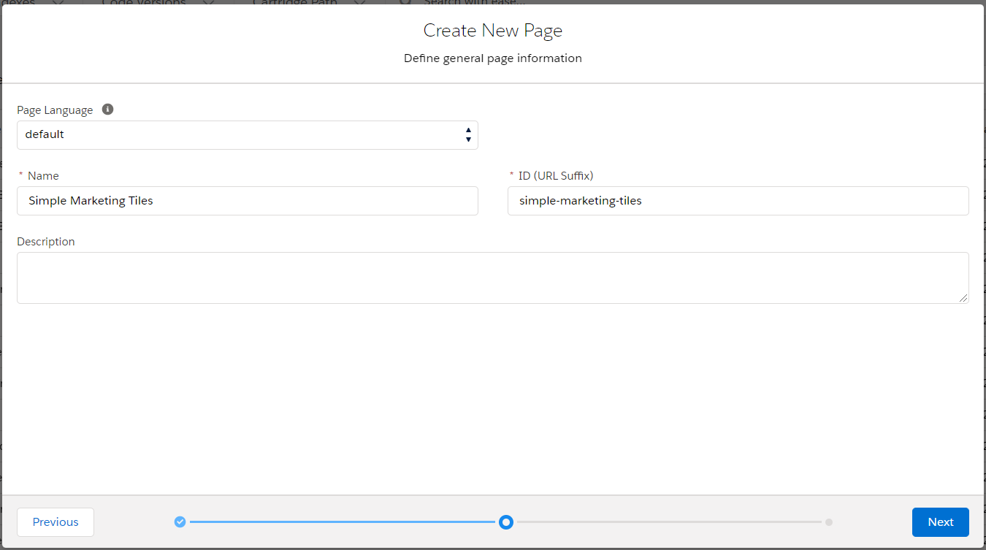

1. At **Main Region**, click ‘**+**’ sign and select ***PD Plus 3 Row x 1 Col (Mobile), PD Plus 1 Row x 3 Col (Desktop)*** from **PD_LAYOUTS** section and then fill your customize settings and then press **Save** Button.

|  |  |
| --- | --- |
| Field Name | Value |
| Component Settings |  |
| Layout Fluid | Checked |
| Specify Background Color | #5679C0 |
| Specify Background Color Alpha between 0 and 1 i.e 0.2 |  |
| Specify Background Image |  |
| Specify Image Alt text | San Francisco background image |
| UI Layout Settings |  |
| Padding Top |  |
| Padding-Right |  |
| Padding-Bottom |  |
| Padding Left |  |
| Margin Top | 20px |
| Margin Right |  |
| Margin Bottom |  |
| Margin Left | 20px |

**Note:** (The default value for Background Color Alpha is 70. You may select your desired value from dropdown).

1. **Sample Image:**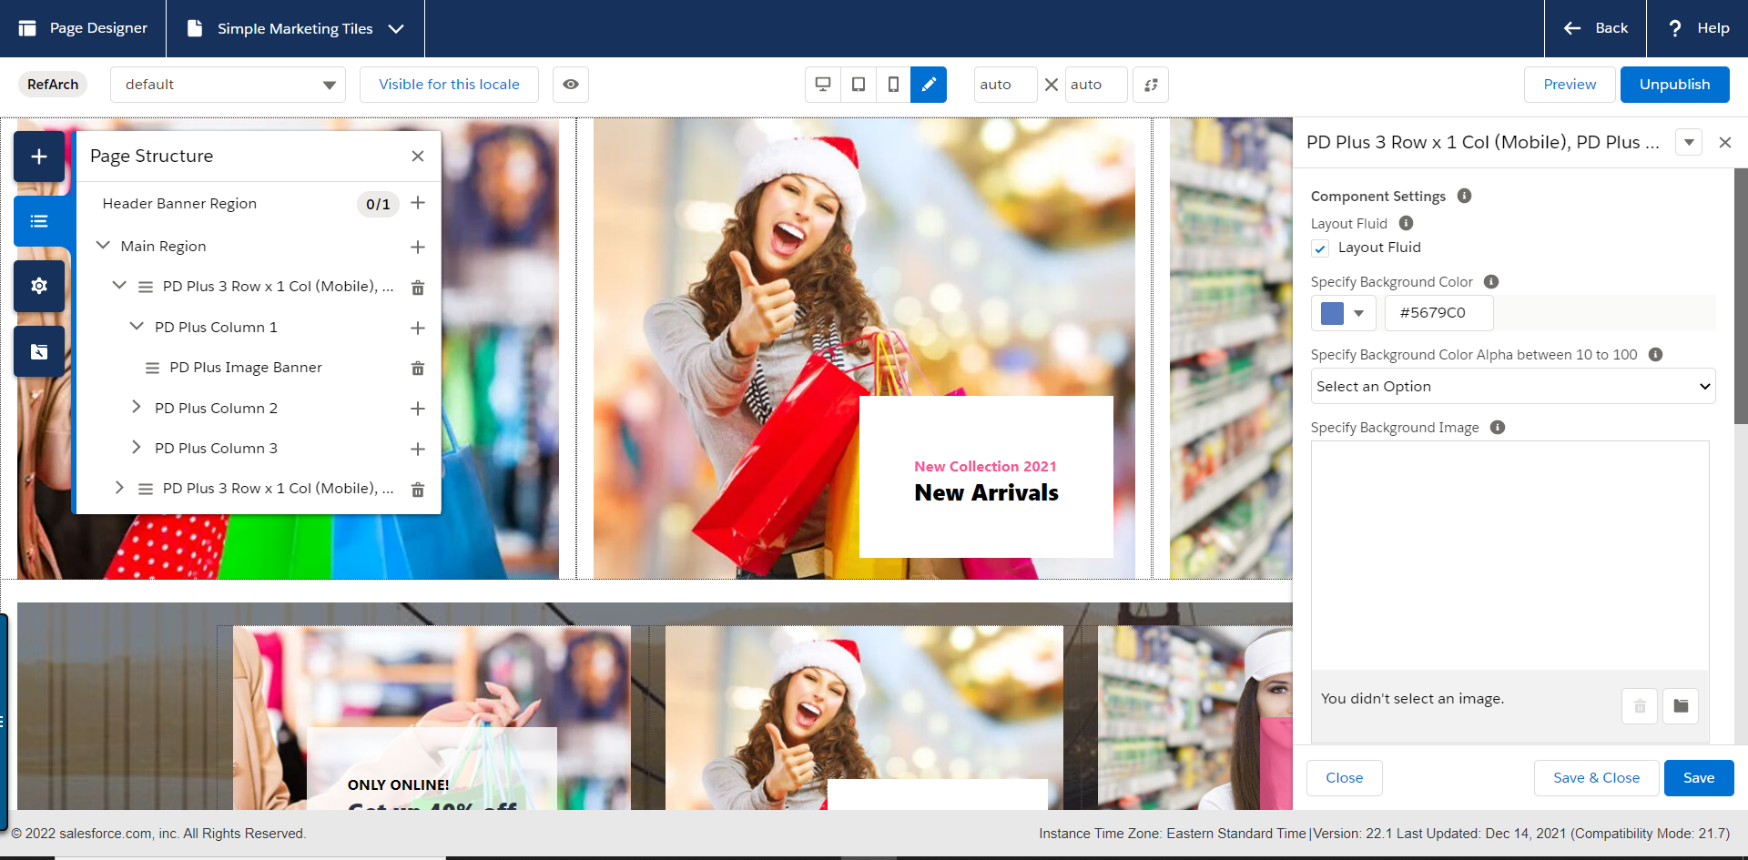
2. For each column of ***PD Plus 3 Row x 1 Col (Mobile), PD Plus 1 Row x 3 Col (Desktop)*** click ‘**+**’ and add **PD Plus Image Banner** from **PD_ASSETS**.
3. The sample configurations of **PD Plus Image Banner Component** and sample data are as follows:  
     
   Sample Data for **First** PD Plus Image Banner Component



|  |  |
| --- | --- |
| Field Name | Value |
| Custom Tile Configurations |  |
| CSS Class Name | Set your desired CSS Class Name |
| Link of Tile | Choose URL by pressing Create Button |
| New Tab | Unchecked |
| Scale Image on Hover | Unchecked |
| Position of Card along y-axis | center |
| Position of Card along x-axis | Center |
| Tile Image | documentation /images/demo/tiles/tile-one.jpg |
| Alternate Text of Image | Tile First |
| Title Text | ONLY ONLINE! |
| Title Text Color | #000000 |
| Tile Card Caption background color | #FFFFFF |
| Tile Card Caption background color opacity | 0.8 |
| Sub Text | Get up 40% off |
| Color Sub Text | #5679C0 |

Sample Data for **Second** PD Plus Image Banner Component

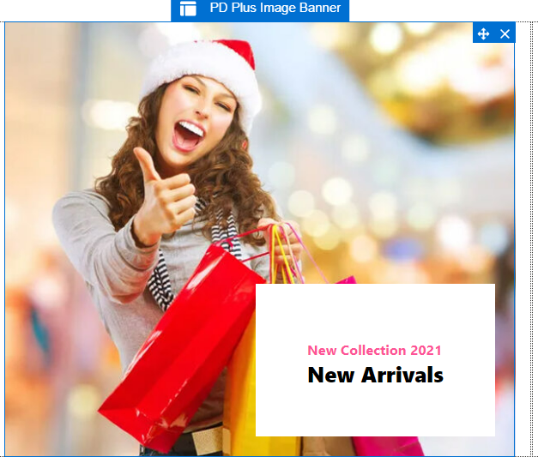

|  |  |
| --- | --- |
| Field Name | Value |
| Custom Tile Configurations |  |
| CSS Class Name | Set your desired CSS Class Name |
| Link of Tile | Choose URL by pressing Create Button |
| New Tab | Unchecked |
| Scale Image on Hover | Unchecked |
| Position of Card along y-axis | Flex-end |
| Position of Card along x-axis | Flex-start |
| Tile Image | meta/images/demo/tiles/tile-second.jpg |
| Alternate Text of Image | Tile Second |
| Title Text | New Collection 2021 |
| Title Text Color | #fd5397 |
| Tile Card Caption background color | #FFFFFF |
| Tile Card Caption background color opacity | 1 |
| Sub Text | New Arrivals |
| Color Sub Text | #000000 |

Sample Data for **Third** PD Plus Image Banner Component

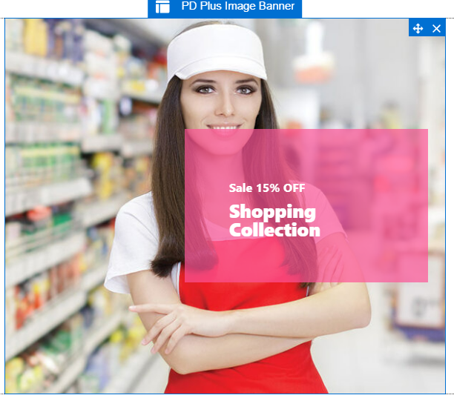

|  |  |
| --- | --- |
| Field Name | Value |
| Custom Tile Configurations |  |
| CSS Class Name | Set your desired CSS Class Name |
| Link of Tile | Choose URL by pressing Create Button |
| New Tab | Unchecked |
| Scale Image on Hover | Checked |
| Position of Card along y-axis | Center |
| Position of Card along x-axis | Flex-start |
| Tile Image | meta/images/demo/tiles/tile-third.jpg |
| Alternate Text of Image | Tile Third |
| Title Text | Sale 15% OFF |
| Title Text Color | #FFFFFF |
| Tile Card Caption background color | #fd5397 |
| Tile Card Caption background color opacity | 0.7 |
| Sub Text | Shopping Collection |
| Color Sub Text | #FFFFFF |

**Note:** (The default value for Background Color Alpha is 70. You may select your desired value from dropdown, the sample images are referenced and shared in folder).

|  |  |
| --- | --- |
|  |  |

1. Press Save, Publish and Preview.  
    **Preview Page:**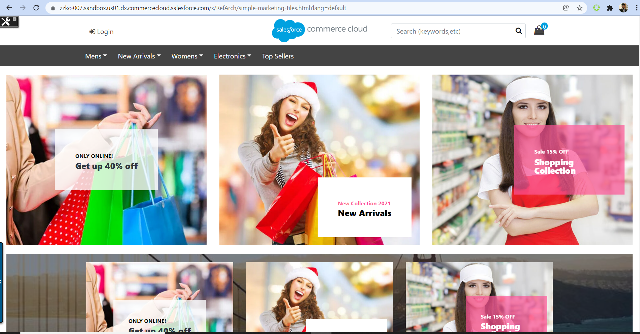

### Use Case B: Configuring Advance Overlay Marketing Tiles Component

**Navigate to Merchant Tools > Page Designer**

1. Create a new page by clicking **New**,select **PDPlus Storefront Page** and then click **Next**



1. Add Name, ID, Description (optional) of your page and press **Next** button and then press **Save & Create** button  
   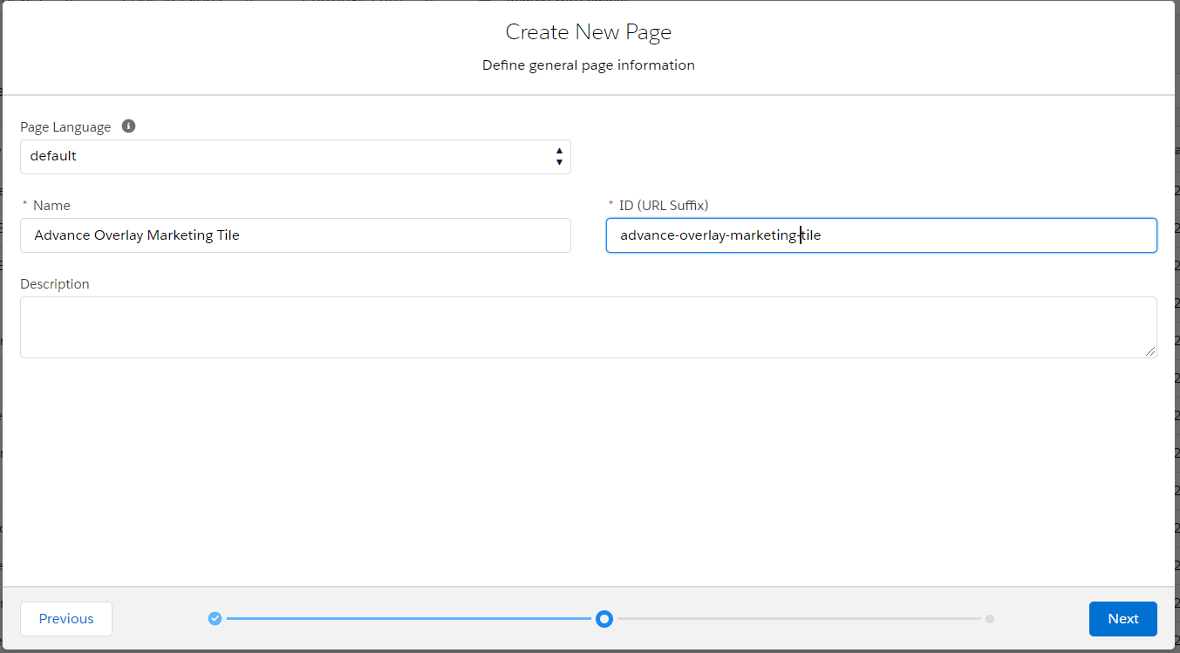
2. From Main Region, Click ‘+’ sign and select **PD Plus 3 Row x 1 Col (Mobile), PD Plus 1 Row x 3 Col (Desktop)** from **PD_LAYOUTS**  
   Do your desired settings. The sample data is as follows:

|  |  |
| --- | --- |
| Field Name | Value |
| Component Settings |  |
| Layout Fluid | Unchecked |
| Specify Background Color | #000000 |
| Specify Background Color Alpha between 0 and 1 i.e 0.2 |  |
| Specify Background Image | meta/images/demo/sanfranciscobackground3.jpg |
| Specify Image Alt text | San Francisco background image |
| UI Layout Settings |  |
| Padding Top | 30px |
| Padding-Right | 15px |
| Padding-Bottom | 30px |
| Padding Left | 15px |
| Margin Top | 20px |
| Margin Right |  |
| Margin Bottom |  |
| Margin Left | 20px |

1. For each column in **PD Plus 3 Row x 1 Col (Mobile), PD Plus 1 Row x 3 Col (Desktop)** click ‘+’ and choose **PD Plus Image Hover Effects** component from **PD_ASSETS**. The sample data for each component with its preview are:  
     
   Sample data for ***First*** **Advance Overlay Marketing Tile**:

|  |  |
| --- | --- |
|  |  |

|  |  |  |
| --- | --- | --- |
|  |  |  |

|  |  |
| --- | --- |
| Field Name | Value |
| Image Hover Component Configs |  |
| Tile ID |  |
| Enable Hover Effects | Checked |
| Tiles background Color with opacity e.g rgba(0,0,0,0.1) | rgba(0,0,0,.8) |
| Tiles Text Color e.g #000000 or rgba(0,0,0,1) | #ffffff |
| Select Effect Name | Imghvr-slide-left |
| Image Source | meta/images/demo/tiles/tile-one.jpg |
| Object Fit | cover |
| Image Alt Text |  |
| Title of Image | ONLY ONLINE! |
| Paragraph of Image | Get up 40% off |
| Link URL | Select by clicking Create Button |
| Link Text | Type your desired Button Text |
| Flex Direction | Column |
| Flex Wrap | wrap |
| Position of Text Horizontally | center |
| Position of Text Vertically | Center |
| Image Hover Component Filters |  |
| Blur image | Checked |
| Brightning image | Unchecked |
| Contrast image | Unchecked |
| Shadow below image | Unchecked |
| Hue image | Unchecked |
| Hue Invert | Unchecked |
| Opacity | Unchecked |
| Image Saturation | Unchecked |
| Image sepia | Unchecked |

Sample data for ***Second*** **Advance Overlay Marketing Tile**:

|  |  |
| --- | --- |
|  |  |

|  |  |  |
| --- | --- | --- |
|  |  |  |

|  |  |
| --- | --- |
| Field Name | Value |
| Image Hover Component Configs |  |
| Tile ID |  |
| Enable Hover Effects | Checked |
| Tiles background Color with opacity e.g rgba(0,0,0,0.1) | rgba(253,83,151,.8) |
| Tiles Text Color e.g #000000 or rgba(0,0,0,1) | #ffffff |
| Select Effect Name | Imghvr-push-down |
| Image Source | meta/images/demo/tiles/tile-third.jpg |
| Object Fit |  |
| Image Alt Text |  |
| Title of Image | New Collection 2021 |
| Paragraph of Image | New Arrivals |
| Link URL | Select by clicking Create Button |
| Link Text | Type your desired Button Text |
| Flex Direction | Column |
| Flex Wrap | wrap |
| Position of Text Horizontally | center |
| Position of Text Vertically | Center |
| Image Hover Component Filters |  |
| Blur image | Unchecked |
| Brightning image | Unchecked |
| Contrast image | Unchecked |
| Shadow below image | Unchecked |
| Hue image | Unchecked |
| Hue Invert | Unchecked |
| Opacity | Unchecked |
| Image Saturation | Unchecked |
| Image sepia | Unchecked |

Sample data for ***Third*** **Advance Overlay Marketing Tile**:

|  |  |
| --- | --- |
|  |  |

|  |  |  |  |
| --- | --- | --- | --- |
|  |  |  |  |

|  |  |
| --- | --- |
| Field Name | Value |
| Image Hover Component Configs |  |
| Tile ID |  |
| Enable Hover Effects | Unchecked |
| Tiles background Color with opacity e.g rgba(0,0,0,0.1) | rgba(252,184,59,1) |
| Tiles Text Color e.g #000000 or rgba(0,0,0,1) | #000000 |
| Select Effect Name |  |
| Image Source | meta/images/demo/tiles/tile-second.jpg |
| Object Fit |  |
| Image Alt Text |  |
| Title of Image | Sale 15% OFF |
| Paragraph of Image | Lorem ipsum dolor sit amet, consectetur adipiscing elit. Vivamus pellentesque leo at ante vehicula imperdiet. Mauris in dignissim sapien, quis feugiat quam. |
| Link URL | Select by clicking Create Button |
| Link Text | Type your desired Button Text |
| Flex Direction | Column |
| Flex Wrap | Wrap |
| Position of Text Horizontally | Start |
| Position of Text Vertically | Center |
| Image Hover Component Filters |  |
| Blur image | Unchecked |
| Brightning image | Unchecked |
| Contrast image | Unchecked |
| Shadow below image | Unchecked |
| Hue image | Unchecked |
| Hue Invert | Unchecked |
| Opacity | Unchecked |
| Image Saturation | Unchecked |
| Image sepia | Unchecked |

1. Press Save, Publish and Preview Page.  
     
   **Sample Preview Image**:  
     
   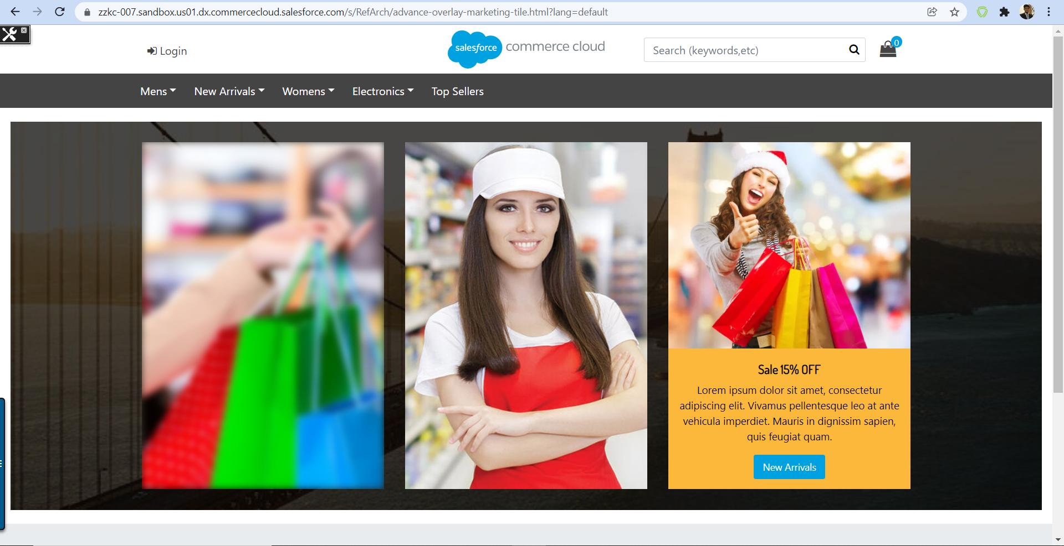

#### 

### Content Asset Component

Salesforce commerce cloud page designer provides Text editor to include HTML inside a page. But the OOTB editor is very limited in terms of styling and caching. Whereas merchants are already familiar with Concept of content assets. So in order to give full control over the HTML being rendered page designer plus provides Content Asset component which allows merchant to provide **content asset id** to the component and it will be rendered where ever its included. This component resolves the limitation and customization required to include a content asset in page designer generated pages

#### Use Case: Configuring Content Asset component.

**Navigate to Merchant Tools > Page Designer**

1. Create a new page by clicking **New**,select **PDPlus Storefront Page** and then click **Next**



1. Add Name, ID, Description (optional) of your page and press **Next** button and then press **Save & Create** button  
   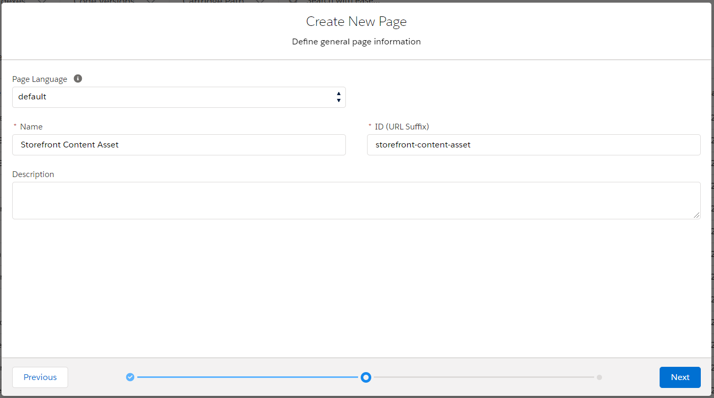
2. From **Main Region**, click ‘+’ sign and select **PD Plus Grid 1Rx1C** from **PD_LAYOUTS**  
   Do your desired settings. The sample data is as follows:

|  |  |
| --- | --- |
| Field Name | Value |
| Component Settings |  |
| Layout Fluid | Checked |
| Specify Background Color | #000000 |
| Specify Background Color Alpha between 0 and 1 i.e 0.2 |  |
| Specify Background Image | meta/images/demo/sanfranciscobackground3.jpg |
| Specify Image Alt text | San Francisco background image |
| UI Layout Settings |  |
| Padding Top | 40px |
| Padding-Right | 30px |
| Padding-Bottom | 40px |
| Padding Left | 30px |
| Margin Top | 20px |
| Margin Right |  |
| Margin Bottom |  |
| Margin Left | 20px |

1. In column of **PD Plus Grid 1Rx1C**, click ‘+’ and choose **PD Plus Content Asset** component from **PD_ASSETS**. The sample data for this component with its preview is shown below:

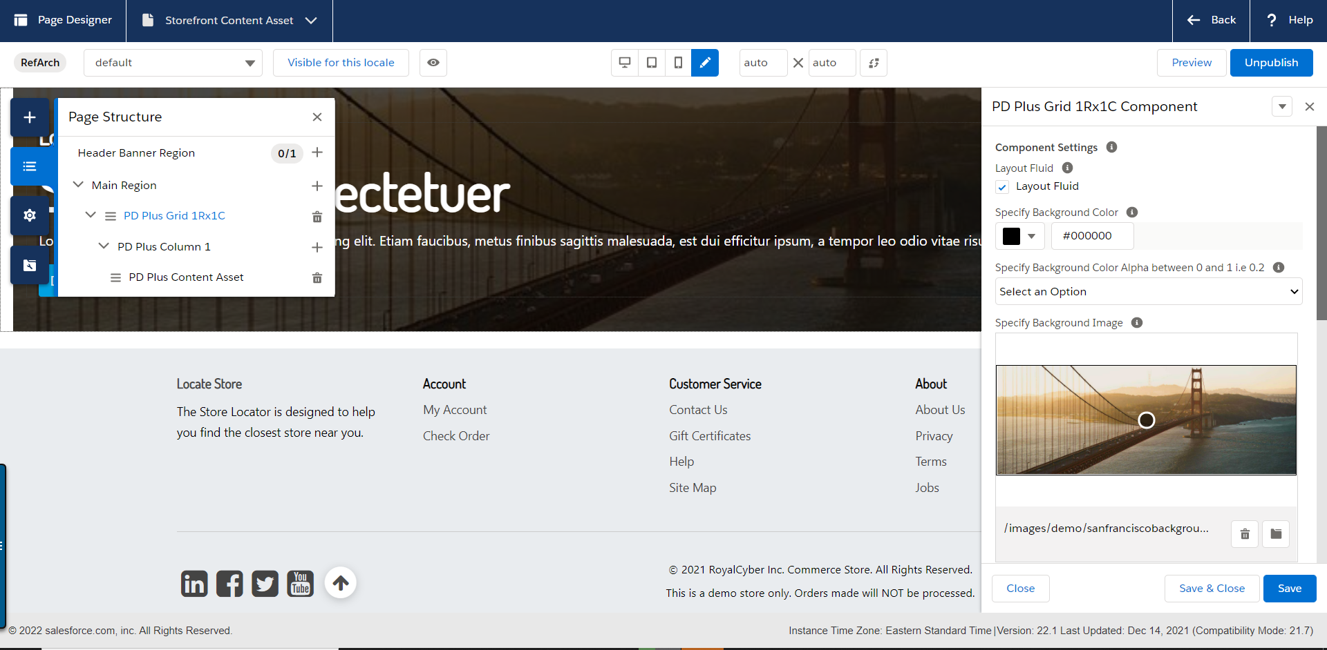

|  |  |
| --- | --- |
| Field Name | Value |
| Content Asset Configurations |  |
| Specify the content asset ID | Select your desired Content Asset ID |
| Specify the Class Name |  |

Press Save, Publish and Preview. The preview page is shown below.  
  
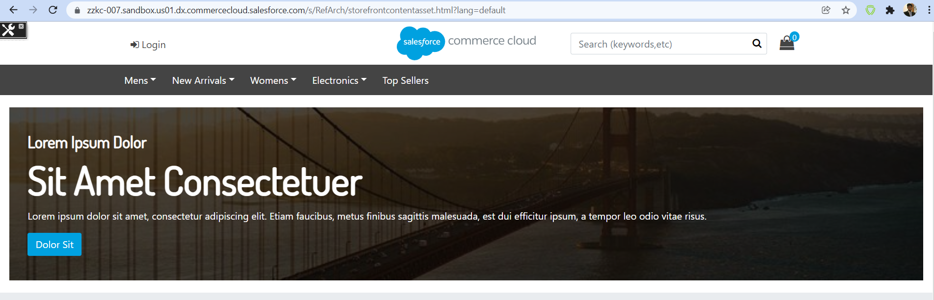

## Limitations, Constraints

Page designer plus requires SFRA base cartridge and Page designer plugin Module cartridge in cartridge path to work. Page designer plus is built on top of example page designer plugin cartridge which allows to reuse some of the components in order not to reinvent the wheel and add value. The page designer plus cartridge contains some new components and some examples extended PLP layout for page designer to demonstrate use of these components.

## Compatibility

Page designer plus is compatible and tested with SFRA version 6.00. it’s also compatible with code version 19.10 and latest.

## Privacy, Payment

*No Privacy data is accessed using this integration.*

# Implementation Guide

## 

## Setup of Business Manager

**Confirm Compatibility Mode**

Your site must be using compatibility mode 17.7 or higher in order for the example page types and component types in this repository to work correctly.

**To enable Page Designer, in Business Manager:**

Select Administration > Global Preferences > Feature Switches.

Enable Page Designer beta.

Read and agree to the terms.

Click Apply.

***Dependencies to download***

*The cartridge code needs following repositories to work. Please download and review their documentation of GitHub regarding installing them by clicking on links below.*

* 1. [*SFRA version 6.0*](https://github.com/SalesforceCommerceCloud/storefront-reference-architecture/tree/v6.0.0)
  2. [*page-designer-reference*](https://github.com/SalesforceCommerceCloud/page-designer-reference)

***Install Cartridges***

* *Clone or fork this repository.*
* *Upload* ***module_pagedesigner*** *and* ***bm_pagedesigner*** *to your sandbox.*
* *upload* ***app_page_designer_plus*** *to your sandbox.*
* *Add* ***bm_pagedesigner*** *to the cartridge path of the Business Manager site.*
* *Add* ***module_pagedesigner*** *to the end of the cartridge path for your storefront site.*
* *Add* ***app_page_designer_plus*** *to the front of the cartridge path for the storefront site.*
* *For an SFRA site, the cartridge path would look like this:* ***app_page_designer_plus:app_storefront_base:module_pagedesigner***

***Cartridge Path Assignment***

* ***Site path:*** *app_page_designer_plus:app_storefront_base:module_pagedesigner*
* ***Business Manager Path:*** *bm_pagedesigner:bm_app_storefront_base*

*Page designer plus has a command* ***“build”*** *run the command to build* ***css,js,fonts and images.***

***Compiling code : npm run build***

***Linting Code: npm run lint***

***Order of compilation:***

*Please note that keep order of compilation such that first SFRA base, page-designer-reference and then page designer plus cartridge needs to be compiled. .*

## Configuration

**Bunsiness Manager Configurations:**

*No Configurations required Other than making sure page designer is enabled in your Instance for latest version of SFRA its available by default.*

***Package.json Configurations:***

*Package.json can be updated to update the path to SFRA base cartridge as page designer plus uses some fonts and styles from SFRA in order to reuse code. Else developer can override them in* ***app_page_designer_plus*** *cartridge*

*Assuming you have downloaded the required cartridges in following folder hierarchy*

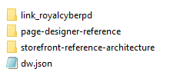

*You will need to update your package.json base path to SFRA base cartridge as following*

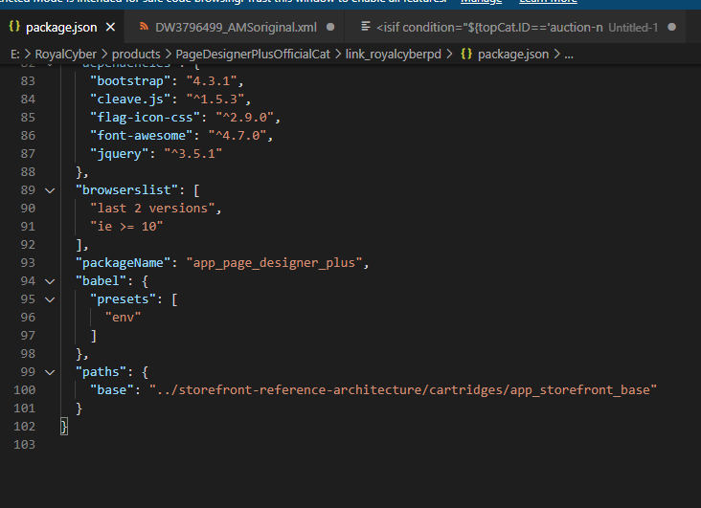

## Localization

*The* ***app_page_designer_plus*** *cartridge contains properties files that you can submit to be localized for the example page types, component types, and component type groups. When you add your own page types and component types, or if you modify the examples, you will need to update the properties files accordingly. For Now Page designer plus supports following locales default English, fr_FR, it_IT, ja_JP, zh_CN*

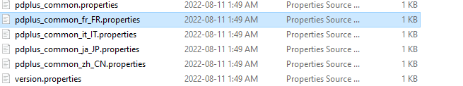

## Custom Code

No changes required

## External Interfaces

None

## Firewall Requirements

No Changes required.

For further information and tutorials about solution please visit

[*https://royalcyber.atlassian.net/wiki/spaces/PDP/overview*](https://royalcyber.atlassian.net/wiki/spaces/PDP/overview)

# Testing

Refer use cases for testing No Explicit Test Run scripts are required.

# Operations, Maintenance

## Data Storage

No Custom objects are used for this integration. OOTB system objects are used to save data for pages.

## Availability

*Dependent on salesforce*

## Failover/Recovery Process

*No webservices involved not applicable.*

## Support

*<CONTACT EMAIL IN CASE DEFECT FIXES OR IMPROVEMENTS FOR COMPONENT ARE REQUIRED>*

# User Guide

## Roles, Responsibilities

*This cartridge can be used by content designer to build pages using components and layout available with the cartridge*

## Business Manager

*Standard Page Business Manager module will be used to use these components.*

## Storefront Functionality

# Known Issues

*No issues reported to date.*

# Release History

|  |  |  |
| --- | --- | --- |
| **Version** | **Date** | **Changes** |
| 22.1.0 | 2022-01-01 | Initial release |